Summary of Changes to

MedDRA® DATA RETRIEVAL
AND PRESENTATION:
POINTS TO CONSIDER

ICH-Endorsed Guide for MedDRA Users on
Data Output

Release 3.9
Based on MedDRA Version 18.0

1 March 2015

The following is a listing of changes made between releases 3.8 and 3.9 of the MedDRA Data Retrieval and Presentation: Points to Consider document.

Throughout document

- Correction of general spelling, punctuation, spacing, figure numbering, and format errors
- Replacement of references to MedDRA Version 17.1 to Version 18.0
- Update of examples based on MedDRA version changes

2.6 – MedDRA Versioning

The Example tables in this section:

Example

Impact of Version Changes – Demoted PT
PT Chest tube insertion was included in a query developed using terms in MedDRA Version 17.0. If the query had been re-run on data using MedDRA Version 17.1, these events would not have been found at the PT level because PT Chest tube insertion had been demoted to an LLT and linked to
PT Thoracostomy.
See Figure 3.

Example

Impact of Version Changes – Change of Primary SOC Assignment
PT Urinary bladder rupture had a primary link to SOC Injury, poisoning and procedural complications and a secondary link to SOC Renal and urinary disorders in MedDRA Version 17.0. In Version 17.1, the primary SOC assignment was changed to SOC Renal and urinary disorders and the secondary assignment to SOC Injury, poisoning and procedural complications. In a primary SOC output of data, PT Urinary bladder rupture will seem to have “disappeared” from SOC Injury, poisoning and procedural complications.

Were changed as follows:

Example

Impact of Version Changes – Demoted PT
PT Mycotic aneurysm was included in a query developed using terms in MedDRA Version 17.1. If the query had been re-run on data using MedDRA Version 18.0, these events would not have been found at the PT level because PT Mycotic aneurysm had been demoted to an LLT and linked to
PT Infective aneurysm.
See Figure 3.
Example

Impact of Version Changes – Change of Primary SOC Assignment
PT Dry gangrene had a primary link to SOC Skin and subcutaneous tissue disorders and a secondary link to SOC Vascular disorders in MedDRA Version 17.1. In Version 18.0, the primary SOC assignment was changed to SOC Vascular disorders and the secondary assignment to SOC Skin and subcutaneous tissue disorders. In a primary SOC output of data, PT Dry gangrene will seem to have “disappeared” from SOC Skin and subcutaneous tissue disorders.

4.5 – SMQs and MedDRA Version Changes

The Example table in this section:

Example

Consequence of Version Mismatch of Coded Data and SMQ
PT Thyrotoxic cardiomyopathy was added to SMQ Cardiomyopathy in MedDRA Version 17.1. Using Version 17.0 of this SMQ – which does not contain this PT – would fail to identify cases coded to this term in a database using MedDRA Version 17.1.

Was changed as follows:

Example

Consequence of Version Mismatch of Coded Data and SMQ
PT Radiation associated cardiac failure was added to SMQ Cardiac failure in MedDRA Version 18.0. Using Version 17.1 of this SMQ – which does not contain this PT – would fail to identify cases coded to this term in a database using MedDRA Version 18.0.

6.2.1 Current members of the ICH Points to Consider Working Group

The table of current members was replaced and updated as follows:

Affiliation | Member
Commission of the European Communities | Maria Luisa Casini
 | Kavita Chadda
European Federation of Pharmaceutical Industries and Associations | Hilary Vass*
 | Christina Winter†
Health Canada | Alison Bennett
 | Polina Ostrovsky
 | Lynn Macdonald
Japanese Maintenance Organization | Yutaka Nagao
 | Kazuyuki Sekiguchi
 | Mitsuru Takano
 | Reiji Tezuka
Japan Pharmaceutical Manufacturers Association | Yo Tanaka
 | Hitomi Takeshita
MedDRA MSSO | Judy Harrison
Ministry of Health, Labour and Welfare/Pharmaceuticals and Medical Devices Agency | Yuhei Fukuta
 | Miki Ohta
 | Daisuke Sato
 | Makiko Isozaki
 | Kiyomi Ueno
Pharmaceutical Research and Manufacturers of America | Milbhor D’Silva
 | JoAnn Medbery
US Food and Drug Administration | Sonja Brajovic#
 | Christopher Breder
Ministry of Food and Drug Safety, Korea | YuBin Lee
 | Kyung-Eun Yoon
World Health Organization | Daisuke Tanaka

* Current Rapporteur
# Regulatory Chair
† Former Rapporteur

6.2.2 Former members of the ICH Points to Consider Working Group

The table of former members was replaced and updated as follows:

Affiliation | Member
Commission of the European Communities | Dolores Montero; Carmen Kreft-Jais; Morell David; Sarah Vaughan
European Federation of Pharmaceutical Industries and Associations | Barry Hammond†; Reinhard Fescharek†
Health Canada | Heather Morrison; Michelle Séguin; Heather Sutcliffe; Bill Wilson
Japanese Maintenance Organization | Osamu Handa; Akemi Ishikawa; Yasuo Sakurai; Yuki Tada
Japan Pharmaceutical Manufacturers Association | Takayoshi Ichikawa; Akemi Ishikawa; Satoru Mori; Yasuo Sakurai;  Kunikazu Yokoi
MedDRA MSSO | JoAnn Medbery; Patricia Mozzicato
Ministry of Health, Labour and Welfare/Pharmaceuticals and Medical Devices Agency | Tamaki Fushimi; Wakako Horiki; Sonoko Ishihara; Kazuhiro Kemmotsu; Tatsuo Kishi; Chie Kojima; Emiko Kondo; Hideyuki Kondou; Kemji Kuramochi; Tetsuya Kusakabe; Kaori Nomura; Izumi Oba; Shinichi Okamura; Yoshihiko Sano; Nogusa Takahara; Kenichi Tamiya; Daisuke Tanaka; Shinichi Watanabe; Takashi Yasukawa; Go Yamamoto; Manabu Yamamoto; Nobuhiro Yamamoto
Pharmaceutical Research and Manufacturers of America | David Goldsmith; Sidney Kahn; Anna-Lisa Kleckner; Susan M. Lorenski; Margaret M. Westland†
US Food and Drug Administration | Miles Braun; Andrea Feight; John (Jake) Kelsey†; Brad Leissa; Toni Piazza-Hepp

† Former Rapporteur

6.3 Figures

Figure 1: The examples (related to MedDRA version changes) for this figure:

OTHER TERMINOLOGY  PREFERRED TERMS | No. of EVENTS | MedDRA Version 17.1  PREFERRED TERMS | No. of EVENTS
Infection | 15 | Upper respiratory tract infection  Nasopharyngitis  Infection  Lower respiratory tract infection  Skin infection | 7  2  1  4  1
Abdominal pain | 9 | Abdominal pain  Abdominal pain upper  Abdominal tenderness | 4  3  2
Accidental injury | 4 | Injury  Skin laceration  Ligament sprain  Back injury | 1  1  1  1
Figure 1 – How data coded to a single concept from another terminology may be expressed by several PTs in MedDRA

Were changed as follows (note the change of Skin laceration to Laceration):

OTHER TERMINOLOGY  PREFERRED TERMS | No. of EVENTS | MedDRA Version 18.0  PREFERRED TERMS | No. of EVENTS
Infection | 15 | Upper respiratory tract infection  Nasopharyngitis  Infection  Lower respiratory tract infection  Skin infection | 7  2  1  4  1
Abdominal pain | 9 | Abdominal pain  Abdominal pain upper  Abdominal tenderness | 4  3  2
Accidental injury | 4 | Injury  Laceration  Ligament sprain  Back injury | 1  1  1  1
Figure 1 – How data coded to a single concept from another terminology may be expressed by several PTs in MedDRA

Figure 3: The examples (related to MedDRA version changes) for this figure:

Preferred Terms | Events/Cases |  | Comment
 | Version 17.0 | Version 17.1
Chest tube insertion | 15 | 0  (no longer a PT) | In MedDRA Version 17.0, Chest tube insertion was a PT and in Version 17.1 it was demoted to an LLT under PT Thoracostomy
Thoracostomy | 5 | 20
Figure 3 – Impact of MedDRA version changes – demotion of a PT

Were changed as follows:

Preferred Terms | Events/Cases |  | Comment
 | Version 17.1 | Version 18.0
Mycotic aneurysm | 15 | 0  (no longer a PT) | In MedDRA Version 17.1, Mycotic aneurysm was a PT and in Version 18.0 it was demoted to an LLT under PT Infective aneurysm
Infective aneurysm | 5 | 20
Figure 3 – Impact of MedDRA version changes – demotion of a PT

Figure 4: The footnote was changed to indicate that the primary SOC output listing shown is based on MedDRA Version 17.1:

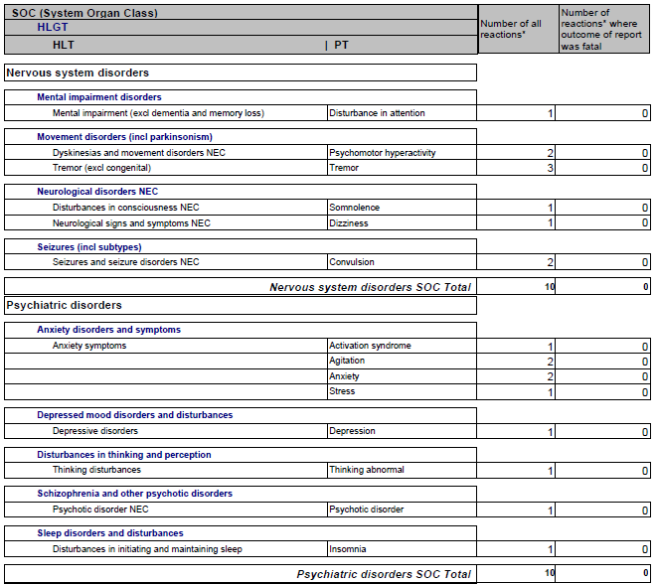
Figure 4 – Primary SOC output listing, MedDRA Version 17.1 – example. Note that some PTs are multiaxial, however, this figure shows only the primary SOC assignments

